Heroku – Deployment

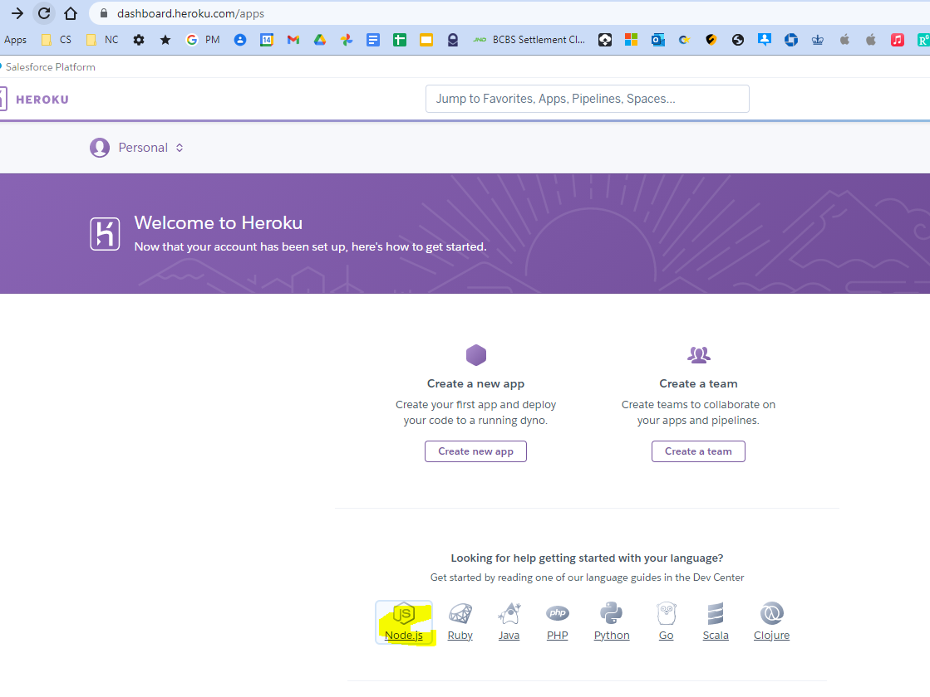

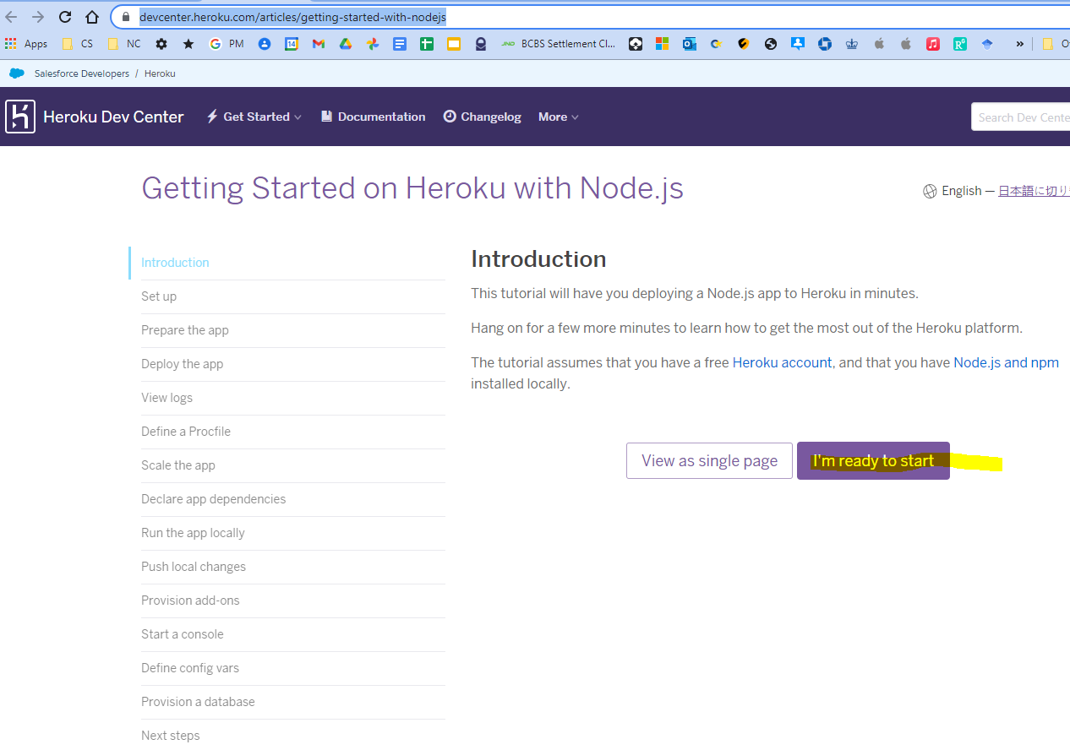

Install the heroku executable (requires git first)

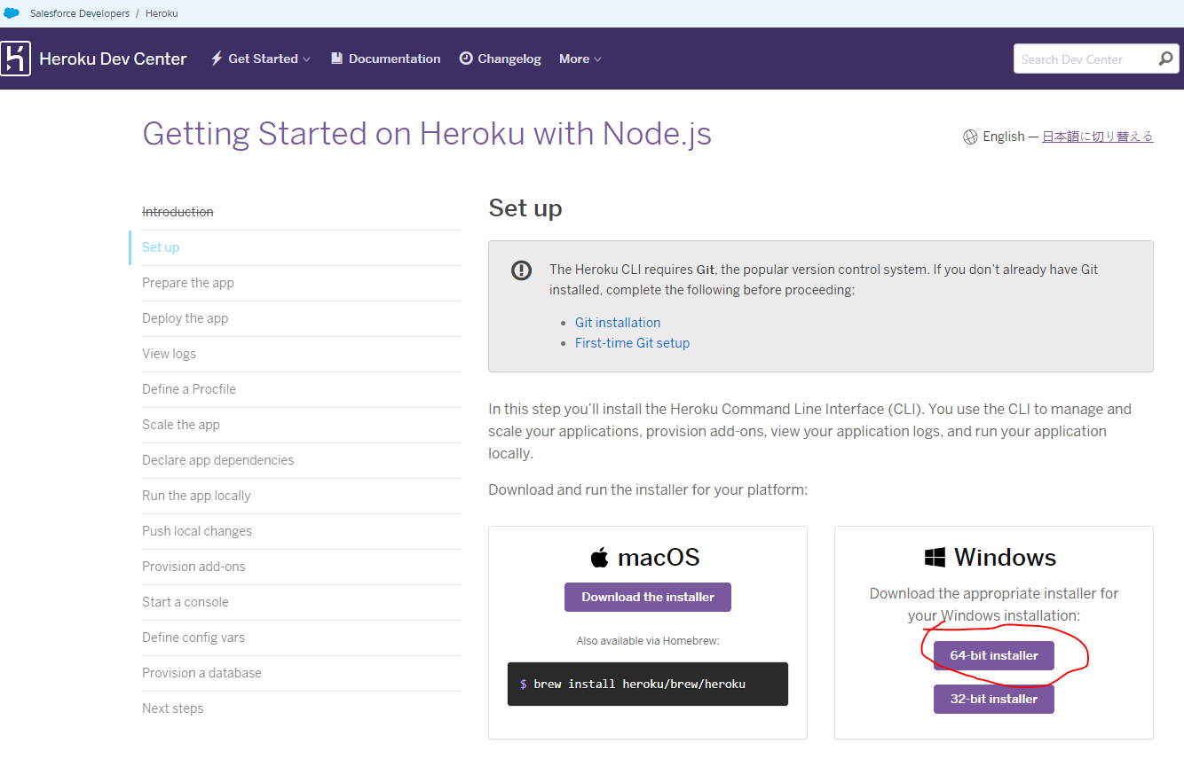

When installation completes, you can use the heroku command from your terminal.

On Windows, start the Command Prompt (cmd.exe) or Powershell to access the command shell.

Use the heroku login command to log in to the Heroku CLI:

$ heroku login

heroku: Press any key to open up the browser to login or q to exit

› Warning: If browser does not open, visit

› https://cli-auth.heroku.com/auth/browser/***

heroku: Waiting for login...

Logging in... done

Logged in as me@example.com

This command opens your web browser to the Heroku login page. If your browser is already logged in to Heroku, simply click the **Log in** button displayed on the page.

The terminal hangs forever. I just closed the window.

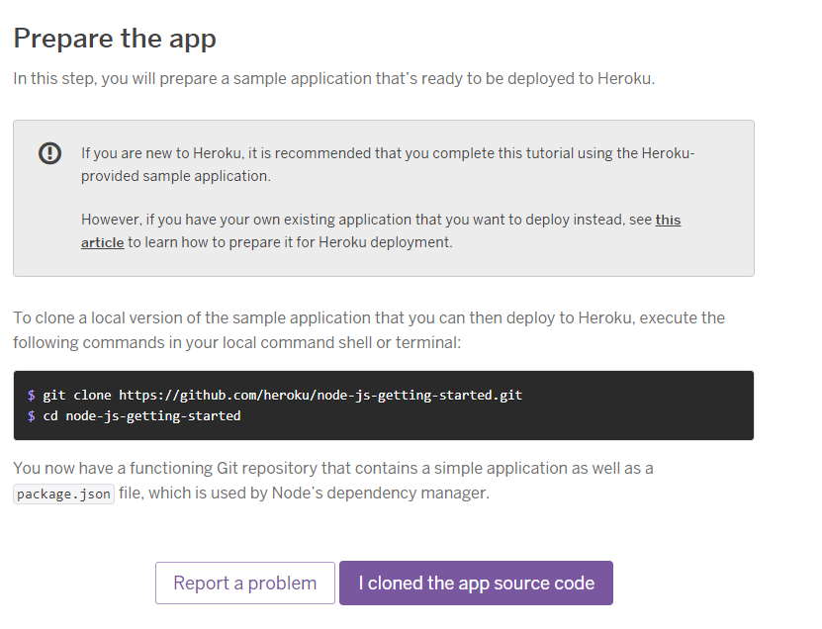

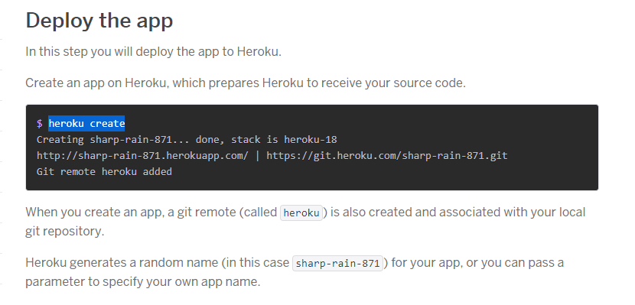

$ heroku create

» Warning: heroku update available from 7.53.0 to 7.59.0.

Creating app... done, mysterious-reaches-28039

https://mysterious-reaches-28039.herokuapp.com/ | https://git.heroku.com/mysterious-reaches-28039.git

mysterious-reaches-28039

Now deploy your code. Note this is same as pushing to repo, but origin is replaced with heroku.

$ git push heroku main

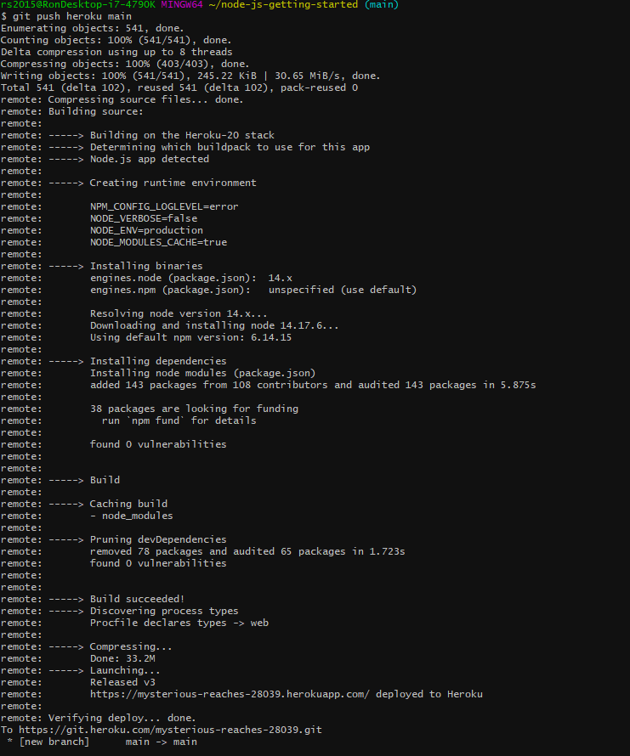

The application is now deployed.

Ensure that at least one instance of the app is running:

$ heroku ps:scale web=1

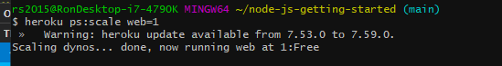

Now visit the app at the URL generated by its app name. As a handy shortcut, you can open the website as follows:

$ heroku open

this opened <https://mysterious-reaches-28039.herokuapp.com/>

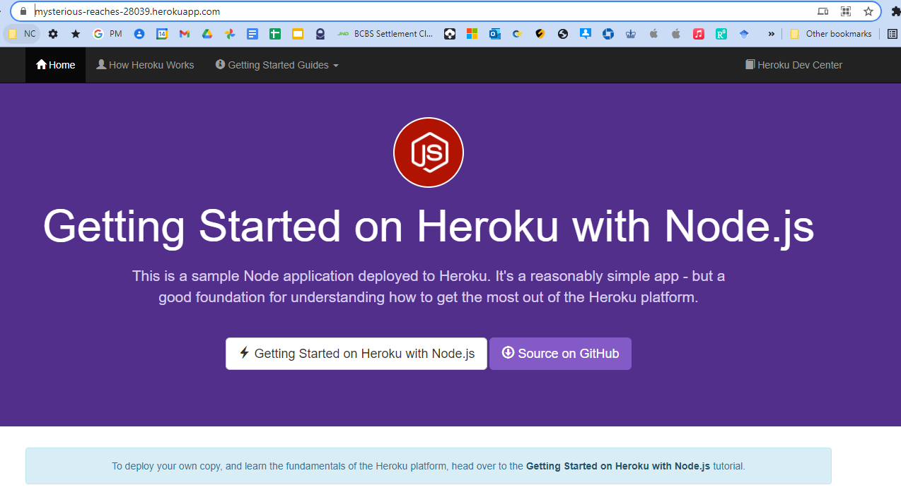

 How this sample app works

* This app was deployed to Heroku, either using Git or by using [Heroku Button](https://github.com/heroku/node-js-getting-started) on the repository.
* When Heroku received the source code, it fetched all the dependencies in the [package.json](https://github.com/heroku/node-js-getting-started/blob/main/package.json), creating a deployable slug.
* The platform then spins up a dyno, a lightweight container that provides an isolated environment in which the slug can be mounted and executed.
* You can scale your app, manage it, and deploy over [150 add-on services](https://addons.heroku.com/), from the Dashboard or CLI.

 Next Steps

* If you are following the [Getting Started](https://devcenter.heroku.com/articles/getting-started-with-nodejs) guide, then please head back to the tutorial and follow the next steps!
* If you deployed this app by deploying the Heroku Button, then in a command line shell, run:
  + git clone https://github.com/heroku/node-js-getting-started.git - this will create a local copy of the source code for the app
  + cd node-js-getting-started - change directory into the local source code repository
  + heroku git:remote -a <your-app-name> - associate the Heroku app with the repository
  + You'll now be set up to run the app locally, or [deploy changes](https://devcenter.heroku.com/articles/getting-started-with-nodejs#push-local-changes) to Heroku

 Helpful Links

* [Heroku](https://www.heroku.com/home)
* [Heroku Dev Center](https://devcenter.heroku.com/)
* [Getting Started on Heroku with Node.js](https://devcenter.heroku.com/articles/getting-started-with-nodejs)
* [Deploying Node Apps on Heroku](https://devcenter.heroku.com/articles/deploying-nodejs)

the git repo README:

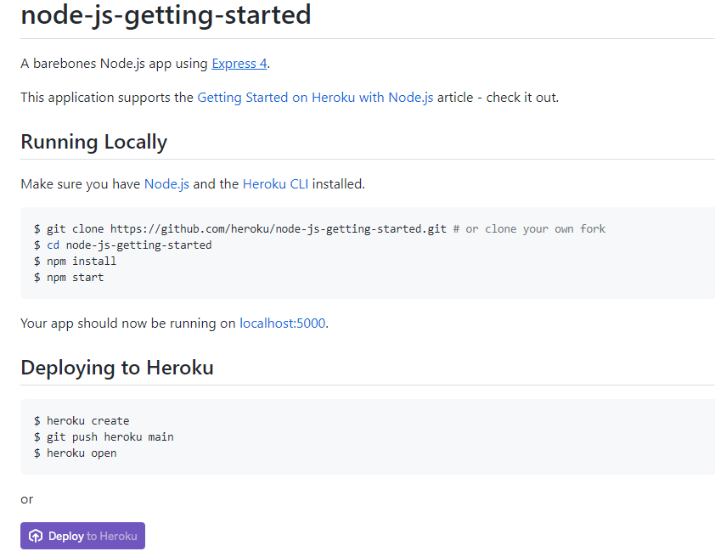

so looks like you just have to have your app setup so that npm start runs it

back to the getting start tutorial

<https://devcenter.heroku.com/articles/getting-started-with-nodejs#view-logs>

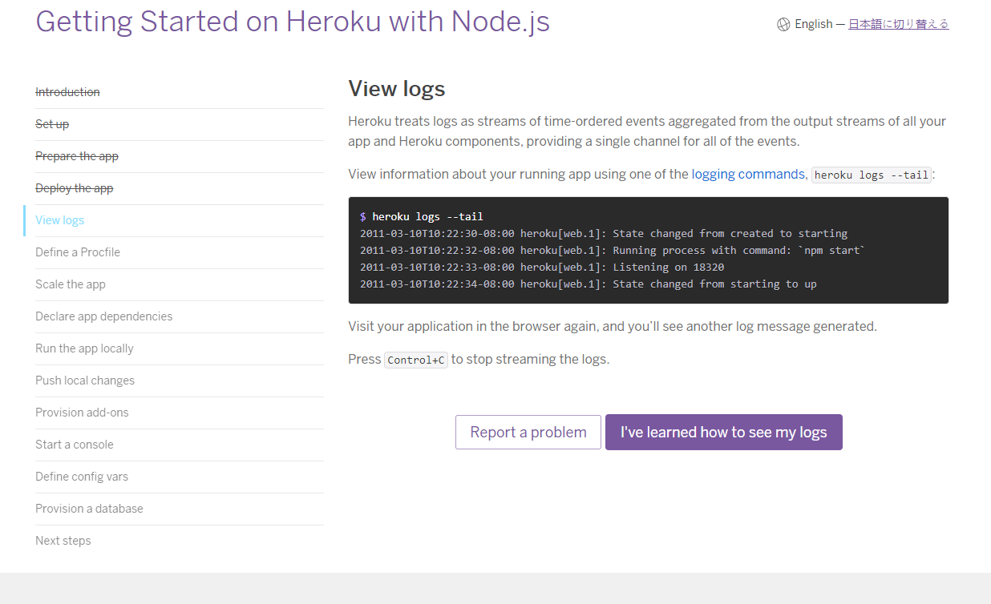

read this regarding package.json files

<https://medium.com/inato/how-to-setup-heroku-with-yarn-workspaces-d8eac0db0256>

<https://betterprogramming.pub/how-to-deploy-multiple-apps-under-a-single-github-repository-to-heroku-f6177489d38>

<https://blog.heroku.com/deploying-react-with-zero-configuration>